Introduction to Network Analysis: Working with Gephi
http://www.modernist-magazines.org
http://gephi.org

Network analysis is a method for modeling the connections among structured data. The program we will use, Gephi, can visualize connections among various types of data in the field of modernist magazines. The datasets provided by the instructor will show you the connectedness among bibliographic data from modernist magazines that were curated by students. The idea is that you might see connections you had not predicted—say, among authors, between magazines and certain authors, or between authors and certain themes. We will want to discuss network analysis as a tool for doing literary history, and also to start thinking creatively about how information systems might be used to ask and answer humanistic questions.

Step 1: Import the Data Into Gephi

- Download the file “little-review-1918-09.csv” onto your computer from the Downloads page of the course site (http://modernist-magazines.org/?q=content/downloads). Be sure to place it where you'll remember to find it (i.e. on the Desktop or in a subfolder of Documents).
- Start Gephi and go to File > Open...
- Browse to little-review-1918-09.csv and open it.
- A dialogue window will ask if you want certain parameters, so make sure Graph Type is set to Directed, and that Auto-scale, Create missing nodes, and Add full graph are all checked. These options should already be set as the default.
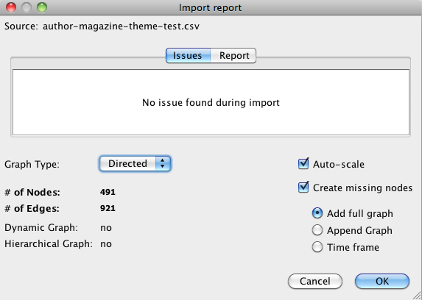
- Once the dialogue appears as in this picture, click OK.

Step 2: Manipulating the Graph and Adding Labels

- Once the data are imported, you'll see a square-ish rat's nest of black dots and lines, some of which are darker than others. Mouse over them to see how their immediate neighbors become highlighted within the graph. These dots represent different nodes within the data (such as author names and magazine titles), and show you the connecting links to other data.
- You'll notice that Gephi doesn't immediately tell you what these dots are, so we need to make their labels visible. Click on the little rectangular arrow at the bottom right of the Graph area to open some options.
- Once the options pane opens across the bottom, click on the Labels tab and then on the checkbox next to Node.
- After a moment, the Graph area will fill with large text, which you should make smaller by clicking on the Font button (under the Node checkbox) and selecting a smaller font size like 8pt.
- Now that the text is smaller, try zooming in to get a closer look, or pulling nodes around, and get a sense of what's in the network model.
- To try a different layout, go to the Layout panel in the left sidebar, select one of the options (such as Yifan Hu) and then click on the Run button.

Step 3: Adding Interpretive Features with Node Size and Color

Gephi can change the visual aspects of its nodes and edges to represent the levels of connectedness among the nodes. For example, the nodes that have more connections, such as the magazine BLAST, will appear larger or in different colors to provide a more immediate conception of where the dominant nodes in the network lie. These features are based on statistical properties that Gephi will compute.

- In the right sidebar, click on the Statistics tab. If it is not there, add it by clicking on the Window menu at the top of the screen and then selecting Statistics.
- Next to Average degree, click on the Run button. You will see some output about the degree densities of the graph.
- Now, in the left sidebar, click on the Ranking tab, and then on the Nodes sub-tab.
- To the right of the Nodes subtab, the Color palette should already be selected.
- Select Degree from the dropdown menu and then click on the Apply button. The nodes should now appear on a scale from red to black (or whatever colors were pre-selected on your version of Gephi).
- Click on the Weight button (looks like a red diamond) to the right of the color palette.
- Select Degree again, leave the default size parameters in place, and click on the Apply button.
- Some of the nodes should now appear larger.

Step 4: Creating Ego Networks

The large-scale graph can be very interesting. However, we might wish to drill down and look at smaller networks in order to enhance our thinking about a particular author, magazine, or theme. Filtering for an ego network (a network centered on a single node) is one way to do this.

- In the right sidebar, click on the Filters tab.
- Expand the Topology folder.
- Drag Ego Network down to the Queries area and then click on it.
- In the Node ID field at the bottom, type in a term from our spreadsheet that you wish to examine, such as BLAST.
- Click on OK and then on Filter to start the Ego Network.
- You will then see a smaller network for those nodes most immediately connected to BLAST.
- You can then adjust the number of degrees out from BLAST shown in the network by selecting 1, 2, 3, or Max from the Depth menu under the Node ID field.

Step 5: Reading the Graphs & the September 1918 Little Review

Write brief answers to the following questions about thin a blog post. Be sure to post screen shots using the camera button in Gephi.

- Play around with the layouts and other visualization widgets to gain a sense of the graph’s content and structure. Does anything seem to be missing? Do you agree or disagree with any of the genre or topic tag connections?
- Select and run the Yifan Hu layout algorithm. What significant groupings and divisions do you notice among the data? How does this relate to our discussion of the September 1918 Little Review? How does it affect your current understanding of the issue?
- Select the Fruchterman Rheingold layout algorithm and try moving the nodes around. Does this layout allow you to read the data any differently than Yifan Hu? How so?
- Does small- or medium-scale network visualization strike you as a useful method for periodical studies? Can you see yourself or others benefitting from a thoroughly marked up issue or set of issues?

